Module 1
1. The concept of an elementary function, an indefinite integral, its properties. Indefinite integral table.
2. Methods of integrating an indefinite integral: substituting under the differential, changing the variable, integrating by parts.
3. Integrating rational expressions. Rational function and its decomposition into a sum of simple fractions. Integrating rational fractions. Method of indefinite coefficients.
4. Describe Ostrogradsky's method.
5. Integration of irrational and trigonometric expressions. Fractional-linear irrationality. Quadratic irrationality. Euler substitutions. Integration of differential binomials.
6. Definite integral and its existence conditions. Definition and properties of a definite integral. Upper and lower Darboux sums, their properties. Riemann integral sum.
7. Properties of a definite integral. A definite integral with a variable upper limit. Newton-Leibniz formula. Methods of integrating a definite integral: substitution of a variable, integration by parts.
8. Application of a definite integral. Arc length. Arc differential. Area of a plane figure.

Module 2
Сalculate the integral:
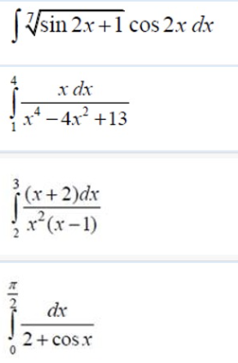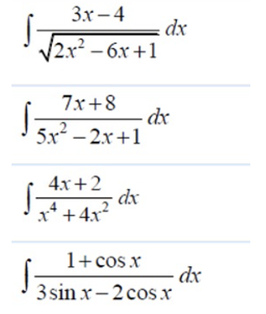

Module 3
